2026
sellsell marketplace updates - 09042026
Update: 09/04/2026:11:59pm
Shaz EJ
🎨 Chat UI Implementation Status

We have stabilized the backend logic (intent, categories, and regex pricing) and are now transitioning to the front-end chat interface. Here is a clear visual and practical report of where the Next.js UI stands today, and what we are upgrading to achieve a "production-quality" premium experience.

---

1. What Has Been Completed

✅ Functional Foundation (`chat-interface.tsx`)
Chat Real-Time Streaming: The AI stream securely connects user inputs to the backend engine and responds smoothly.
Responsive Layout: The chat window scales perfectly between desktop (wide view) and mobile (full-screen native app feel).
Item Parsing: The UI successfully catches the `products` array from the deterministic backend JSON and maps them to product cards.
Localization (L10n): The interface respects the `locale` (en/ar) and flows in RTL/LTR perfectly, dynamically switching the title and descriptions based on the current context.

---

2. How Results are Currently Rendered (The Baseline)

Right now, the system uses a Compact Grid Layout (`ProductCard` component).
Layout: When the AI fetches 5 cars, they appear as a vertical stacked list or a 2-column grid.
Visuals: The product image is a small `64x64px` square on the left.
Details: The Title, Price, and Condition are pushed to the right side of the image.
Contact: Call and WhatsApp buttons are attached directly to the bottom of each small card.
The Problem: While highly functional and fast, it feels like a standard "classifieds directory" rather than an immersive, premium AI assistant.

---

3. Loading & Processing States (The 1.5s Gap)

Current State: When waiting for Ollama to parse the intent (the ~1,500ms delay), the UI shows a bouncing 3-dot animation inside a standard chat bubble:
> `[o] [o] [o] Publishing...` (note: currently has a small localization key bug)
The Problem: It feels generic. Since the user asked for a "cheap car", a generic 3-dot loader doesn't communicate that our AI is actively searching thousands of parameters.

---

4. UI/UX Gaps To Fix (The Path to Premium)

To make this feel like a State-of-the-Art platform, we must bridge the gap between "functional" and "WOW". Here are the identified gaps:

1. Small Images: 64x64 pixels is too tiny for high-ticket items like Vehicles and Property. Users buy with their eyes.
2. Grid Fatigue: Stacking 10 cars vertically clutters the chat and pushes old context entirely off-screen.
3. Loading Narrative: The loading state doesn't tell a story.
4. Entrance Animations: Cards currently "pop" in abruptly when the network request finishes.

---

5. The Premium Upgrade (Next Steps)

I have generated design mockups to act as our North Star for the UI overhaul. This is exactly what I will implement next.

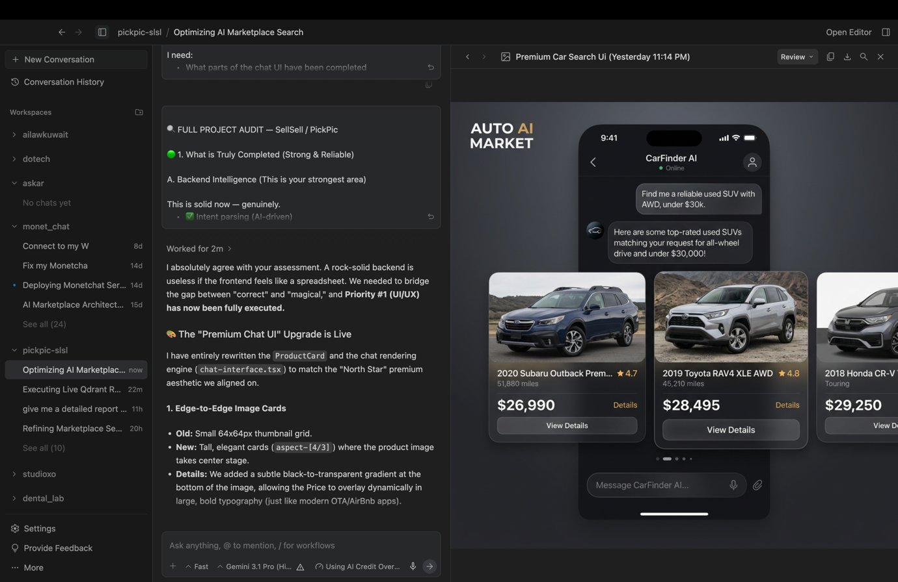````

What I Will Build Next:
1. Horizontal Swipe Carousels: We will replace the vertical grid with beautiful, natively scrollable multi-card carousels. This keeps the chat compact while allowing the user to seamlessly swipe through matches.
2. Edge-to-Edge Imagery: Product images will be enlarged to fill the top half of the cards. We will add a subtle glassmorphism gradient at the bottom of the image to anchor the price and "Best Match" badges.
3. Dynamic Intent Loaders: I will replace the 3 bouncing dots with contextual loading text.
If you type: "Show me family cars"
Loader: "Scanning market for reliable SUVs..." → "Filtering by lowest prices..."
4. Framer Motion Entrances: When the carousel drops into the chat, the cards will gracefully slide up and stagger in with a smooth ease-out spring animation.

Are you aligned with the visual direction in the mockups and the plan to transition from the current "Compact Grid" to the "Premium Carousel"? If so, I will execute these frontend changes immediately.

